Implementing OWASP ZAP DAST Scan in Jenkins Pipeline

Step 1: Create a Jenkins pipeline job to integrate the vulnerability scan tool

- Open the terminal and execute the following commands to install container runtime and Docker tool to proceed with pipeline execution:

sudo apt update

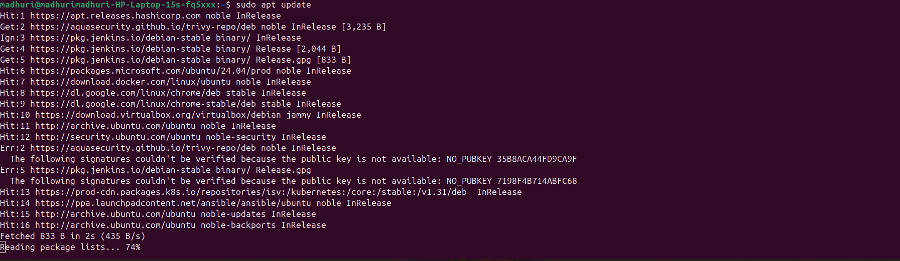

sudo apt install containerd docker.io

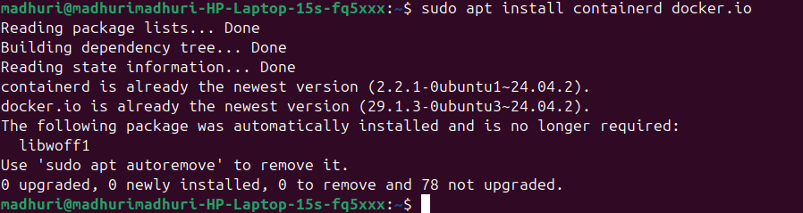

sudo chmod 777 /var/run/docker.sock

sudo service docker restart

- Log in to Jenkins using your credentials
In the Jenkins dashboard, click on New Item
Create a Jenkins pipeline job, click on Pipeline, put Implementing OWASP ZAP DAST Scan in Jenkins Pipeline under Enter an item name, and then click on OK
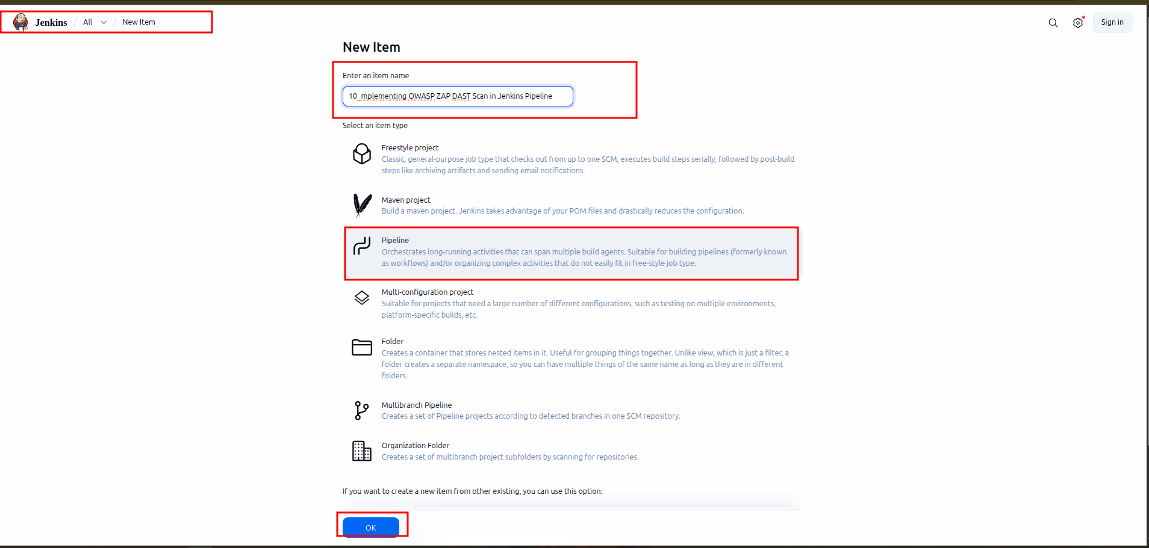

- In the Configure page, click on Pipeline and paste the following code under Script and then click on Save:

pipeline {
agent any
environment {
zapDockerName = "ghcr.io/zaproxy/zaproxy:stable"
}
parameters {
choice(
name: 'SCAN_TYPE',
choices: ['Baseline', 'APIS', 'Full'],
description: 'Type of scan to perform'
)
string(
name: 'TARGET',
defaultValue: 'https://medium.com/',
description: 'Target URL to scan'
)
booleanParam(
name: 'GENERATE_REPORT',
defaultValue: true,
description: 'Generate HTML report'
)
}
stages {
stage('Parameter Initialization') {
steps {
echo """
Scan Type: ${params.SCAN_TYPE}
Target: ${params.TARGET}
Generate Report: ${params.GENERATE_REPORT}
"""
}
}
stage('Setup OWASP ZAP Container') {
steps {
echo 'Removing old container if exists...'
sh '''
docker stop owasp || true
docker rm -f owasp || true
'''
echo 'Pulling latest OWASP ZAP image...'
sh "docker pull ${env.zapDockerName}"
echo 'Starting OWASP ZAP container...'

sh """
docker run -dt \
--name owasp \
${env.zapDockerName} /bin/bash
"""
}
}
stage('Prepare Work Directory') {
when {
expression { params.GENERATE_REPORT }
}
steps {
sh '''
docker exec owasp mkdir -p /zap/wrk
'''
}
}
stage('Run ZAP Scan') {
steps {
script {
if (params.SCAN_TYPE == 'Baseline') {
sh """
docker exec owasp \
zap-baseline.py \
-t ${params.TARGET} \
-r report.html \
-I
"""

} else if (params.SCAN_TYPE == 'APIS') {
sh """
docker exec owasp \
zap-api-scan.py \
-t ${params.TARGET} \
-r report.html \
-I
"""
} else if (params.SCAN_TYPE == 'Full') {
sh """
docker exec owasp \
zap-full-scan.py \
-t ${params.TARGET} \
-r report.html \
-I
"""
} else {
error("Invalid scan type selected")
}
}
}
}
stage('Copy Report') {
when {
expression { params.GENERATE_REPORT }
}
steps {
echo 'Copying report to Jenkins workspace...'
sh '''
docker cp \
owasp:/zap/wrk/report.html \
"${WORKSPACE}/report.html"
'''
}
}
}
post {
always {
echo 'Cleaning up OWASP container...'
sh '''
docker stop owasp || true
sleep 5
docker rm -f owasp || true
'''
archiveArtifacts artifacts: 'report.html', fingerprint: true
cleanWs()
}
success {
echo 'OWASP ZAP Scan completed successfully.'
}
failure {
echo 'OWASP ZAP Scan failed.'
}
}
}
- Now, click on Build Now

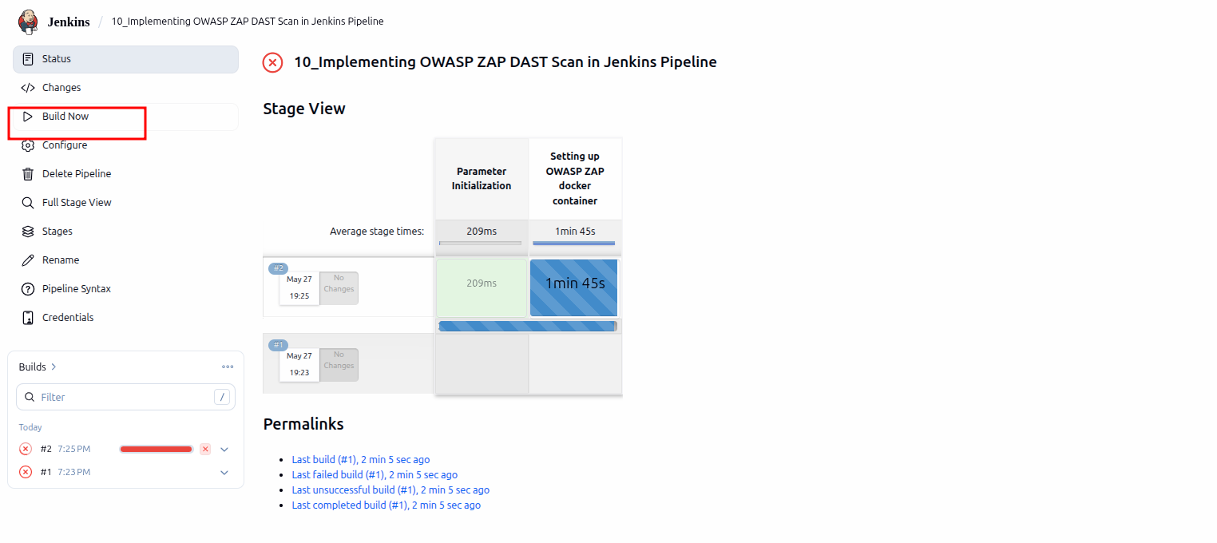

- Initially, the pipeline will fail because it is a parameterized build. Then, Build with Parameters option appears. Click on it to initiate the pipeline with the provided parameters and click on Build.
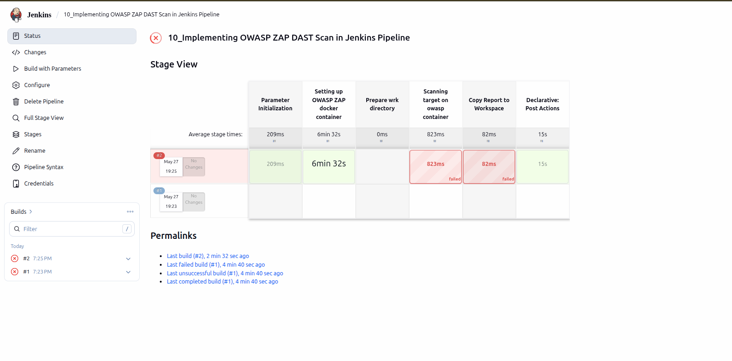

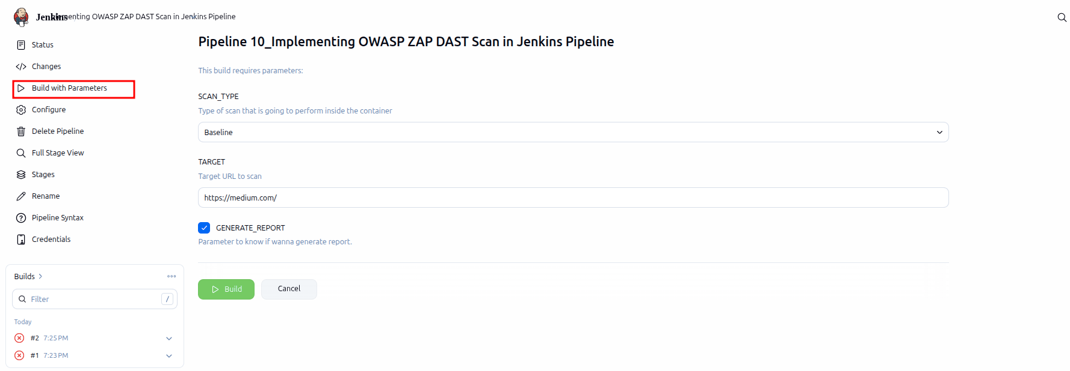

- Navigate back to the Status of the build and click on report.html to see the HTML report archived in Jenkins

